Elevator Safety Compliance and Risk Tracker
Project documentation | Sarth Patel

Part 1: Project documentation
One line: An end-to-end system that finds elevators falling out of inspection compliance, routes them to a work queue daily, and lets a reviewer act on each one, built on real NYC elevator inspection data.

Business problem
Every elevator in NYC must file a CAT1 safety test every year and a CAT5 test every five years. Across tens of thousands of devices, deadlines slip, and a missed deadline means a safety risk and a civil penalty. Nobody has one view of what is compliant, what is due soon, and what is overdue, and nothing tells the right person when to act.

Solution overview
NYC Open Data (CSV)
-> Databricks (bronze -> silver -> gold)
-> Power BI (leadership view)
-> Power Automate (daily flag and route)
-> SharePoint list (work queue)
-> Power Apps (reviewer takes action)

Architecture Diagram
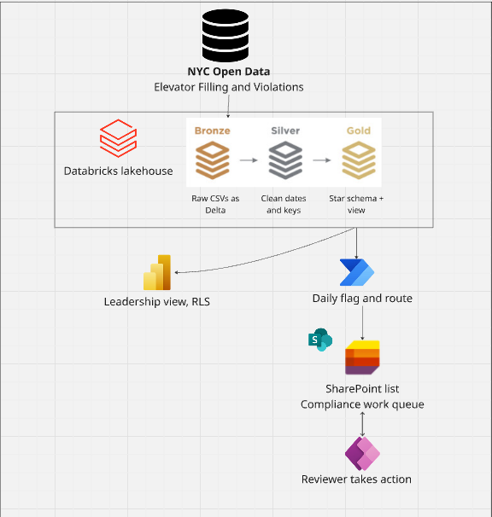

Data sources
Dataset | What it contains
DOB NOW Elevator Safety Compliance | One row per device: status, CAT1/CAT5 filing dates, building ID (BIN), borough, location
DOB Safety Violations | Civil penalties by building, filtered to exclude energy benchmarking violations

Databricks pipeline
- Bronze: raw CSVs loaded as-is into Delta tables, column names standardized.
- Silver: text dates converted to real dates, keys trimmed and standardized, blank IDs removed, duplicates dropped, placeholder dates nulled out.
- Gold: star schema.
  - fact_compliance: one row per active device with CAT1/CAT5 due dates, next due date, days until due, compliance status, open violations.
  - dim_building, dim_device, dim_date.
  - vw_compliance_queue: the view the automation reads (up to 100 Overdue and 100 Due Soon).

Business rules
- CAT1 due: December 31 of the year after the last filing.
- CAT5 due: 5 years after the last filing.
- Next due date: the earlier of the two.
- Status: Overdue (past due), Due Soon (within 90 days), Compliant, or No Record.

Data quality decisions
- Placeholder dates: the first run showed elevators due in 1965, 60 years overdue. Traced to placeholder filing dates in legacy records. Scoped to the current inspection cycle: CAT1 from 2020, CAT5 from 2015.
- Blank building IDs: 51 devices had no BIN, which broke the Power BI relationship. Removed from the building dimension so the model stays one-to-many.
- Duplicate buildings: the building dimension initially had duplicate BINs, creating a many-to-many relationship that would double-count devices. Deduplicated to one row per building.

Power BI
- Overview page: compliance rate, overdue count, open violations, overdue by borough, map by location.
- Detail page: device-level table, most overdue first, drillthrough from the overview.
- Row-level security by borough, so a regional owner sees only their devices.

Power Automate flow: FlagComplianceRisk
- Runs daily on a schedule.
- Queries the Databricks view, then polls until the query finishes (it is asynchronous).
- Reshapes the results into named fields.
- For each device, checks whether it is already in the SharePoint queue. New devices are created with status "New". Existing devices get only their facts updated (status, due date, days until due, violations, last synced).
- Never overwrites the reviewer's fields (action status, assigned to, notes).

SharePoint queue: QueueCompliance
- System fields (the flow owns these): DeviceNumber, BIN, Borough, ComplianceStatus, NextDueDate, DaysUntilDue, OpenViolations, LastSyncedOn.
- Human fields (the reviewer owns these): ActionStatus, AssignedTo, ActionNotes.

Power Apps: Elevator Compliance Queue
- Queue screen: filters by status, borough, and action; search by device; open overdue and due-soon counts; list sorted most urgent first.
- Detail screen: read-only facts on the left, reviewer actions on the right (status, assign to me, notes, mark resolved).

Design principle
The flow owns the facts, the person owns the decision. Automation refreshes status every day, but anything a reviewer has already actioned stays exactly as they left it.

What I would do in production
- Page through the full result set instead of capping at 200.
- Use a service principal instead of personal sign-in for the connection.
- Consider Dataverse instead of SharePoint for larger volumes.
- Add a daily digest email or Teams alert for overdue devices, plus a failure alert.
- Check the organization's data loss prevention policy on connectors before building.

